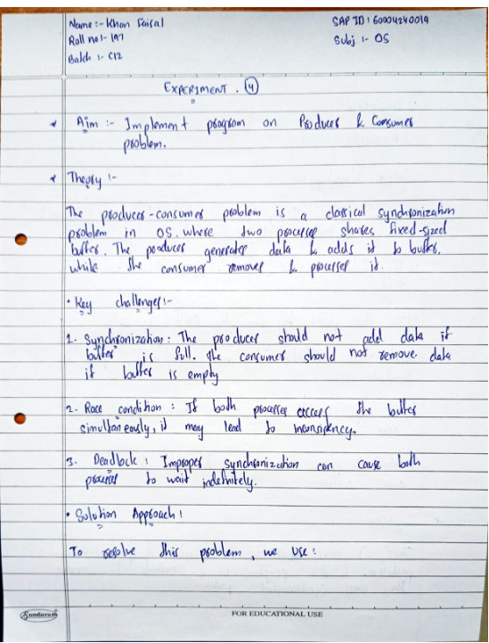

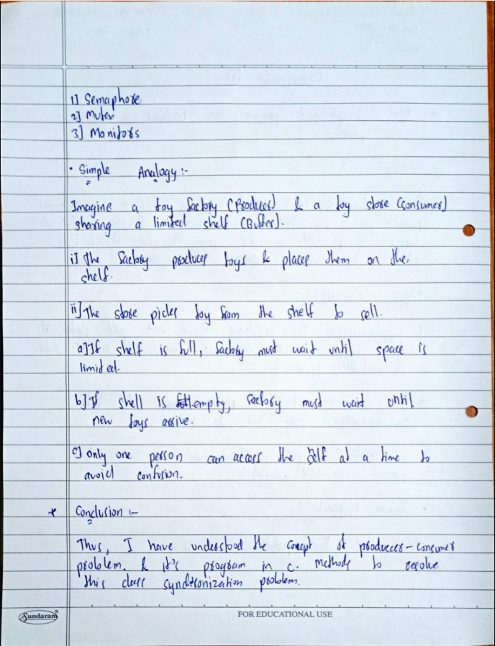

**Program (Sequential Execution):**

#include <stdio.h>

#define BUFFER_SIZE 5

int buffer[BUFFER_SIZE];

int item_count = 0; // Tracks how many items are in the buffer

// Producer: Adds items to the buffer

void produce(int item) {

if (item_count >= BUFFER_SIZE) {

printf("Buffer full! Cannot produce.\n");

return;

}

buffer[item_count++] = item;

printf("Produced: %d\n", item);

}

// Consumer: Removes and processes items from the buffer

int consume() {

if (item_count <= 0) {

printf("Buffer empty! Cannot consume.\n");

return -1; // Error: No item to consume

}

int item = buffer[--item_count];

printf("Consumed: %d\n", item);

return item;

}

int main() {

// Producer adds items

for (int i = 1; i <= 5; i++) {

produce(i);

}

// Consumer takes items

while (item_count > 0) {

consume();

}

return 0;

}

**Output:**

